|  |  |
| --- | --- |
| **ODF Series** | **ODF Unit Box** |
|  |  |

ODF Unit Box is 19" standard cabinet, with high density, large capacity and splicing and distribution integrated unit with all front operation feature. It is suitable for FC, SC, LC, ST adapters, ribbon, and bundle and non-ribbon optical cable. The height is 2U、3U、4U, which can meet the distribution and splice need of 24c、48c、72c.

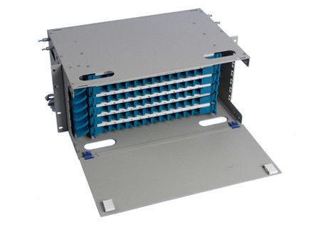

**FEATU**

**FFEATURES**

**●19 ”standard installation structure**

* **Suitable for ribbon optical cable or non-ribbon optical fiber**

**●Fit for FC、SC、ST、LC adapters**

**●Splice module can be taking out, easy to operate**

**●Front-installation .**

**Order Guide for 72 Cores ODF Unit Box**

|  |  |  |  |  |  |  |  |  |  |  |  |  |  |  |  |
| --- | --- | --- | --- | --- | --- | --- | --- | --- | --- | --- | --- | --- | --- | --- | --- |
|  | **No.** |  | **Name** |  |  |  | **Model** |  |  | **Dimension** |  | **QTY** |  | **Remark** |  |
|  |  |  |  |  |  |  |  |  |
|  |  |  |  |  |  |  | **（H*W*D）** |  |  |  |
|  |  |  |  |  |  |  |  |  |  |  |  |  |  |  |
|  |  |  |  |  |  |  |  |  |  |  |  |  |  |
|  | |  |  |  |  |  |  |  |  |  |  |  |  |  |  |
| 1 | |  | 72 ODF termination box | |  |  | GPX311-ZJA-72 | | 176*482*200 | | 1 | |  | Without cable fixing board | |
|  |  |  |  | |  |  |  |  |  |  |  |  |  |  |  |
|  | 2 |  | Splice and distribution |  |  |  | GPX311-YT5-12YD |  |  |  |  | 6 |  | Qty=Core number/12 |  |
|  |  |  |  |  |  |  |  |  |  |
|  |  | integrated tray |  |  |  |  |  |  |  |  |  |
|  |  |  |  |  |  |  |  |  |  |  |  |  |  |  |
|  |  |  |  |  |  |  |  |  |  |  |  |  |  |
|  |  |  |  |  |  |  |  | |  |  |  |  |  |  |  |
|  |  |  |  |  |  |  | FC/PC-1.2M-φ0.9- | |  |  |  |  |  |  |  |
| 3 | |  | 12FO bundle pigtail | |  |  |  |  |  |  | 6 | |  | Model customized; Qty=core number/12 | |
|  |  |  |  |  |  |  | SM-12 | |  |  |  |  |  |  |  |
|  | |  |  | |  |  |  | |  |  |  | |  |  | |
|  | 4 |  | Adapter |  |  |  | FC/PC |  |  |  |  | 72 |  | Model customized; Qty=core number |  |
|  |  |  |  |  |  |  |  |  |  |  |  |  |  |  |  |
| 5 | |  | Splice protection sleeve | |  |  | GPX311-FJ8 | |  |  | 72 | |  | Model customized; Qty=core number | |
|  | |  |  | |  |  |  | |  |  |  | |  |  | |
|  | 6 |  | Bare fiber protection sleeve |  |  |  | GPX311-FJ9Y |  |  |  |  | 12 |  | Model customized; Qty=core number |  |
|  |  |  |  |  |  |  |  |  |  |  |  |  |  |  |  |
| 7 | |  | Crown bolt | |  |  | M5 | |  |  | 4 | |  | Accessory; as required | |
|  | |  |  | |  |  |  | |  |  |  | |  |  | |
|  | 8 |  | Nut |  |  |  | M5 |  |  |  |  | 4 |  | Accessory; as required |  |
|  |  |  |  |  |  |  |  |  |  |  |  |  |  |  |  |
|  |  |  |  |  |  |  |  |  |  |  |  |  |  |  |  |